**6) Cloud Run**

//******************** **Create and deploy Kubernetes Engine** ********************//

Step 1 : Find a github repository for hosting the website : https://github.com/learning-zone/website-templates

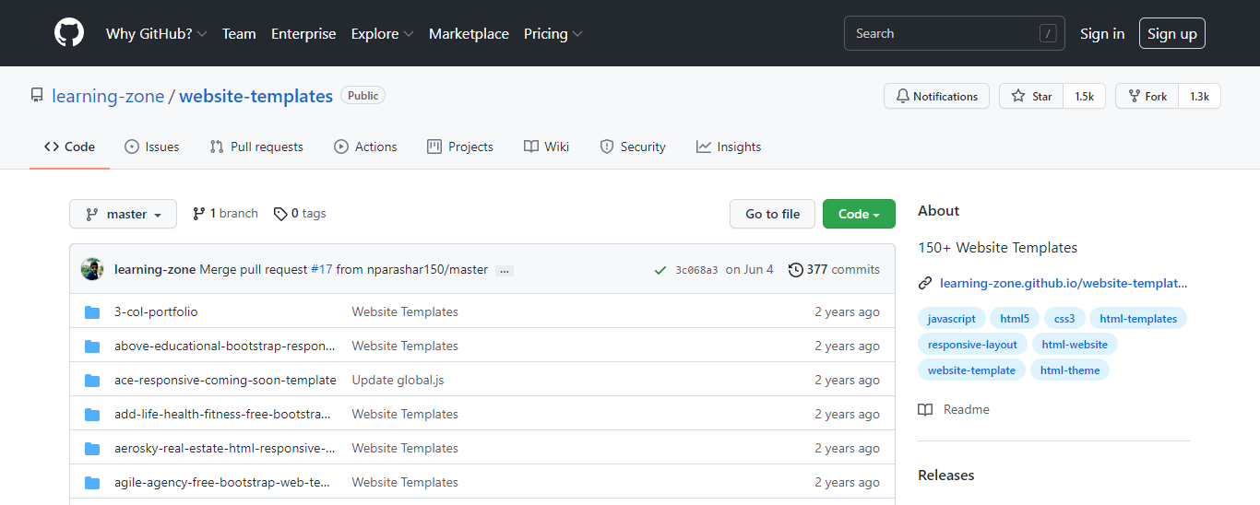

Step 2 : Open the cloud shell and make a directory ‘temp’.

Step 3 : Inside that directory clone the github site using git clone command and then go to the path of github repository which contains the required files.

Step 4 : Create a container using docker run command and view the running containers by using docker ps : docker run -d -p 8080:80 nginx:latest

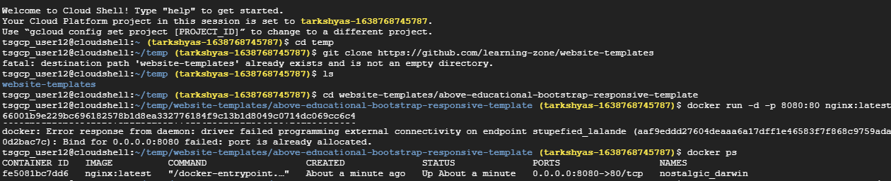

Step 5 : Copy all the files insides github repository to the container by using docker cp command : docker cp about.html fe5081bc7dd6:/usr/share/nginx/html/

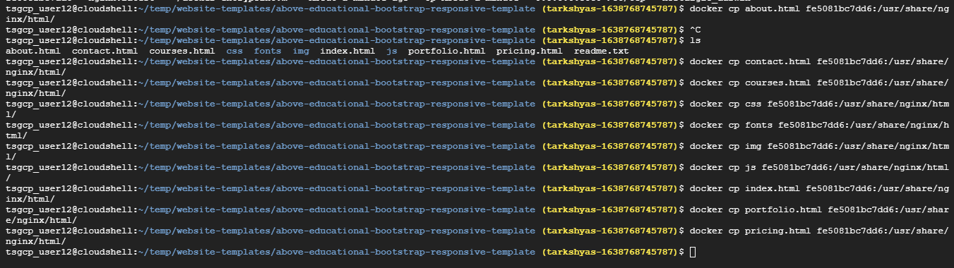

Step 6 : Then commit docker inorder to allow users to take the running container and save its current state as an image : docker commit fe5081bc7dd6 testsite:version1

Step 7 : Share those images to the Docker Hub registry using docker push :

docker tag testsite:version1 us.gcr.io/ tarkshyas-1638768745787/testsite:version1

docker push us.gcr.io/ tarkshyas-1638768745787/testsite:version1

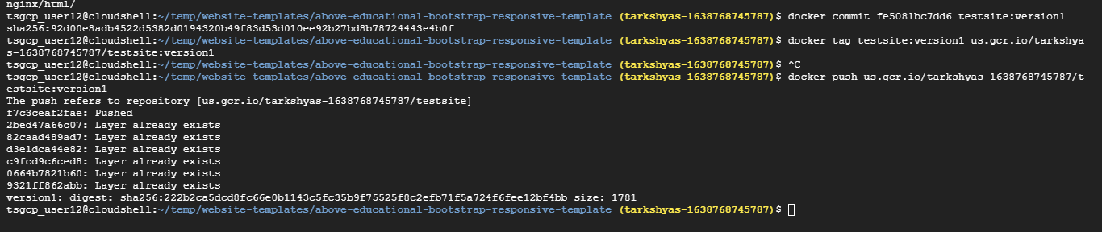

Step 8 : Go to the container registry and view the image created

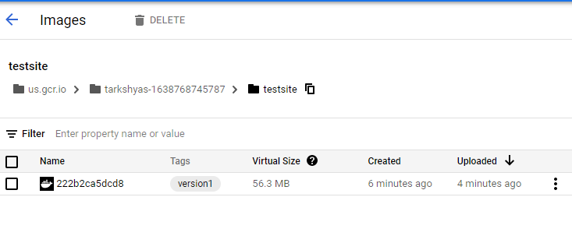

Step 9 : Open Workloads in Kubernetes Engine and deploy the application

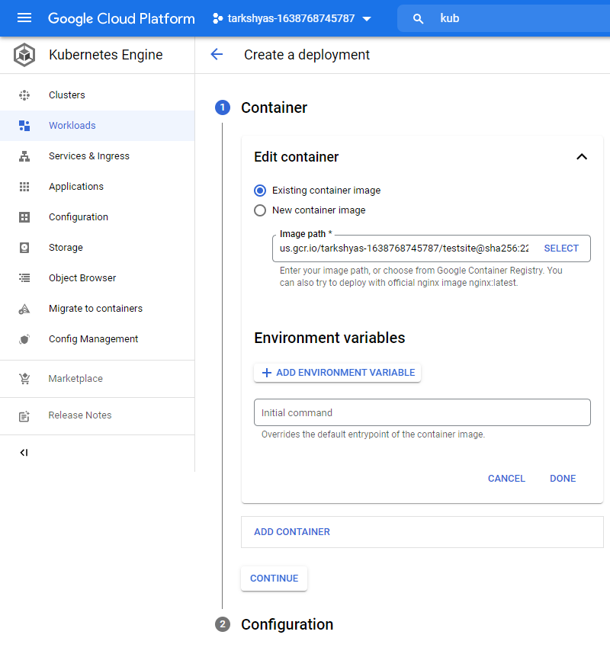

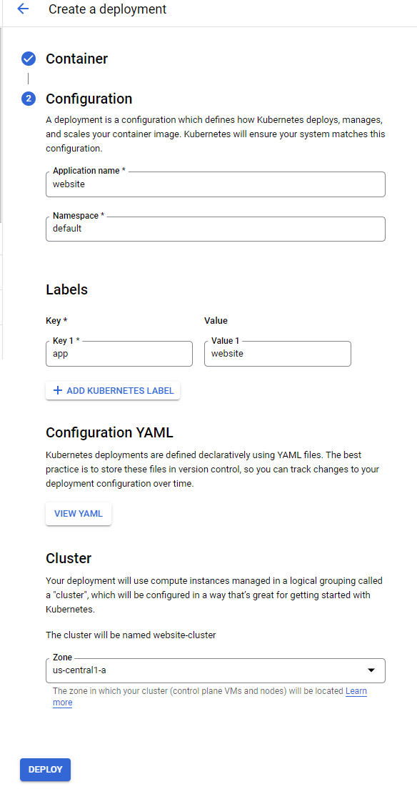

Step 10 : Expose the deployed application

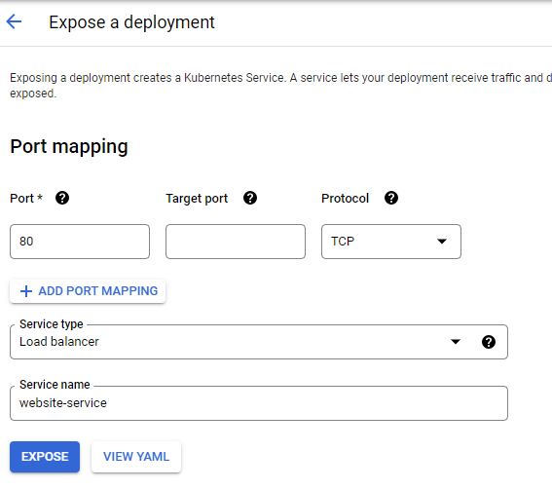

Step 11 : After deployment and expose

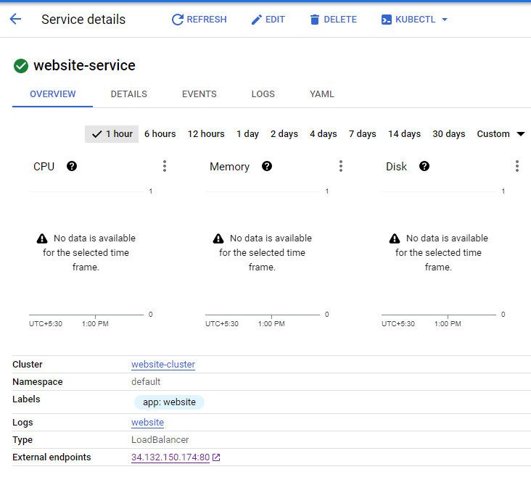

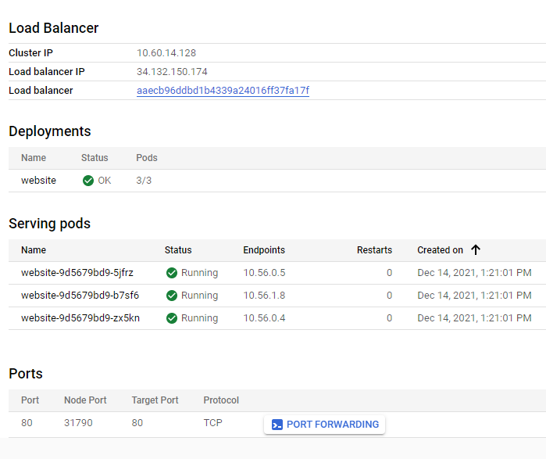

Step 12 : By clicking on external endpoints we get the required website



//************************** **Cloud Run** *******************************//

Step 13 : Open cloud run and create a service with container image url created in container registry

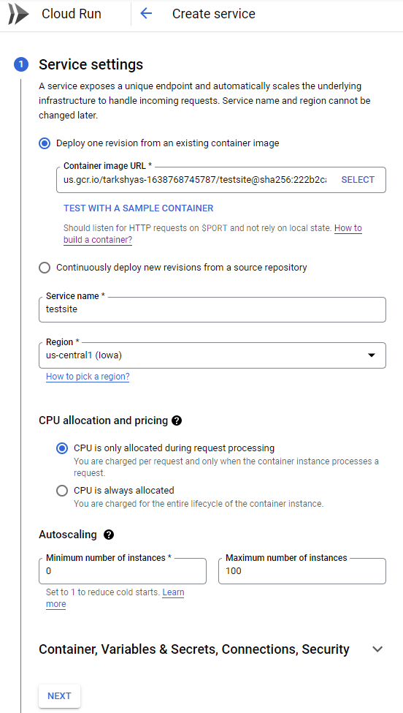

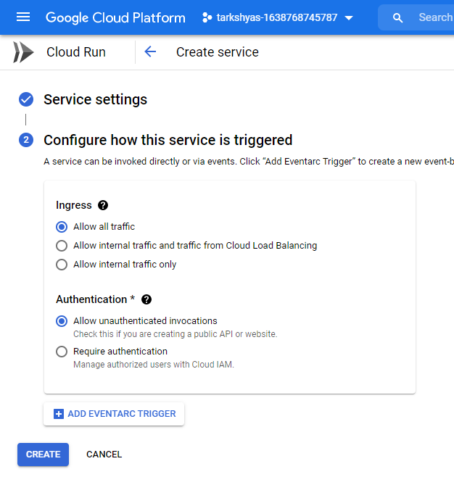

Step 14 : Created service in cloud run which generates a URL leading to the particular site

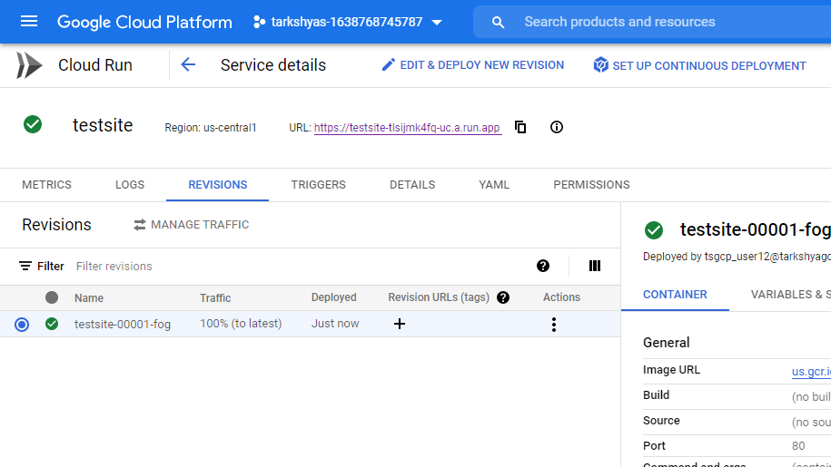

Step 15 : URL redirects to :-

